
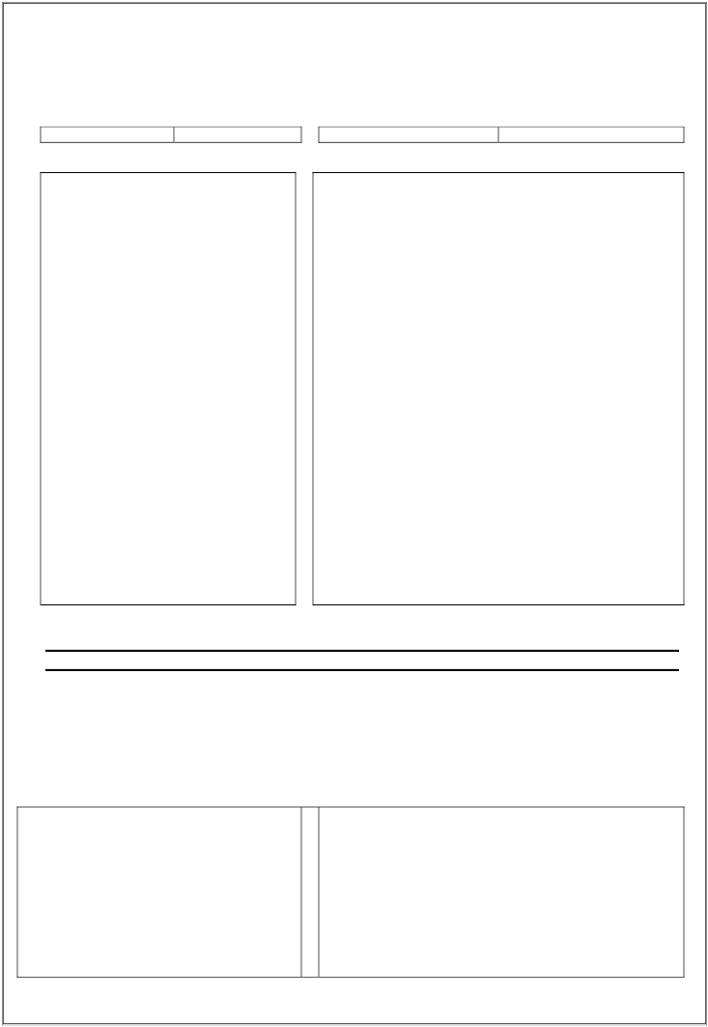
FORM 505
(See rule 62 (2))

Interest payment order under the Maharashtra Value Added Tax Act, 2002

Book No Voucher No.

Interest on Delayed Refund
Counterfoil Order for payment of interest on
delayed refund under The Maharashtra Value
Added Tax Act, 2002
Interest in delayed refund payable to
………………...
Registration Certificate No………………….

Date of Order directing the payment of
interest on delayed refund ……………….
Amount of delayed refund on which interest is
claimed or payable Rs…………..
Amount of interest to be paid on delayed
refund Rs…………………………..
Signature________________
(Designation)__________________
Interest on Delayed Refund
Order for payment of interest on delayed refund under The
Maharashtra Value Added Tax Act, 2002 (Payable at the
Government treasury within three months of the date of issue)
To

The Treasury Officer _____________________________
_____________________________

(1) Certified that with reference to return /appeal record of
_____________ bearing Registration Certificate
No.____________ for the period from __________ to
_______________ an amount of Rs. _________ is/was required
to be refunded to
_______________________________________
_______________________________________
(2) Certified that the payment of the said refund was delayed by the
Sales Tax Officer for a period of ________________ and that
the dealer has claimed / is entitled to interest under section of
the Maharashtra Value Added Tax Act, 2002, for the delay in
granting refund

Date ……………………………………..
Signature of the recipient of the
Voucher……………….

I enclose herewith a certificate from the said M/S______________________________________________

In support of the above statement.
Place Signature

Dated Designation

Date of encashment in the Government Treasury
………………………………….
(3) Certified that the dealer is entitled to Rs.________
as the interest on delayed refund and that no order for the
payment of interest has previously been granted and that this
order for payment of interest has been entered in the original
file of assessment under my signature

Please pay to______________________________
The sum of Rs_____________ In words __________
_________________________

-1-

Date __________
Signature __________
Date of encashment in government treasury ________

Pay Rs.___________________________ Only

Treasury Officer _______________
Received payment
Claimant’s signature ______________________

-2-

